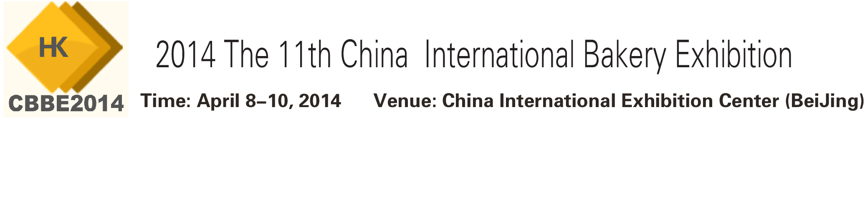

ORGANIZING UNITS
- China National Bakery Food Association（CNBA）
- China National Food Industry Association（CNFIA）
- Beijing JingMao International Exhibition Co., Ltd
Co-organizer:
- Association for Healthcare Foodservice
- China Food Newspaper、China Food Quality Newspaper……
Organized by：
- Beijing JingMao International Exhibition Co., Ltd
- Market Development of China National Food Industry Association
[New starting point, new developments, and new services]
"CBBE China International Baking Exhibition", referred as Beijing Baking Expo, has become a renowned international professional exhibition in the baking industry after10 years of development. In 10 years totally more than 40 countries and regions, 3,800 enterprises have participated the Expo, and got high opinion from domestic and foreign counterparts. CBBE China International Baking Exhibition was awarded the most influential exhibition in the food industry. CBBE’s influence, status of the industry, reliability has been recognized by the industry. CBBE shows the latest developments in China’s baking industry to domestic and foreign counterparts to, and it’s a big stage for baking raw materials manufacturers, and manufacturers for machinery equipment, apparatus; moon cake packaging, moon cake fillings, moon cake production and processing equipment, as well as the grand event for communication and exchange in the baking industry; and the world's largest stage of the baking industry.
China, once a developing country which has now emerged as a newly industrialised nation, has become an engine of the global economy, with ever-increasing opportunities for foreign suppliers and investors. The food industry is one of the fastest-growing sectors and, in accordance with this trend, bread, cakes, pastries and sweets also record a continuous rise in turnover figures.

This trend is more obvious at the Bakery China than anywhere else. The entire range of products and services offered by the baking and confectionery industry is represented at this fair without exception. No matter whether handcrafted bread, cakes and pastries are concerned or large-scale production with state-of-the-art machinery: professional visitors can find first-hand information on current trends, methods and technologies.
On the other hand, the international exhibitors are welcomed by appreciative visitors, since foreign know-how is very much in demand and meets with a keen interest in the market. All this makes the Bakery China a most interesting marketplace where there is a lot happening in every respect.
"CBBE 2014" with "Happy baking Vivid Beijing " as its theme, is scheduled to be held on 8-10 April ，2014 in China International Exhibition Center in Beijing. Concurrent with the food expo, CBBE 2014 is expected to cover 40,000 square meters and receive 60,000 visitors. CBBE will integrate domestic and international trade resources, hold relevant events in the same period, and provide good services to the rapidly developing baking industry with a new start and new breakthroughs.

[Schedule]
Construction: April 6 - 7, 2014
Exhibition: April 8 –9,2014 (09:00 – 17:00)
April 10,2014 (09:00 – 16:00)
Dismantling: April 10,2014 (16:00 – 21:00)

[Scope of Exhibits]
•Bakery and confectionery products
•Raw materials and ingredients for baking
•Decorative materials and products
•Fast food products
•Deep-frozen products
•Baking and pastry-making machinery
•Ovens, devices and tins
•Bakery furnishings and equipment
•Hotel and restaurant furnishings and equipment
•Ice cream＆equipment for ice cream and cold drinks
•Till equipment
•Display equipment
•Refrigeration and deep-freezing technology
•Packaging, packaging materials
•Packaging machinery
•Environmental protection
•Services
•Laboratory technology
•Specialist publishing houses and media
[Participation Fee]
● Standard exhibition booth: 9 m2 (3mx3m); domestic enterprises: joint adventure enterprises /special seporation standard booth 11800 RMB / unit, foreign enterprises: 3000 USD / unit; an additional of 10% will be charged for booths with both opennings;
● Empty exhibition space (at least 36 m² to be leased): Domestic enterprises: 1200 RMB / m²; foreign-funded enterprises: 300 USD / m²;
● Professional seminar / technical exchange fair / new products releasing conference: Cost ￥ 10000 RMB at each show/ half an hour, The sponsor will provide the supporting facilities and supplies such as the sites, lights, sound, projectors, tables and chairs and assist the enterprise giving the speech to organize the audiences
● Ads
● Please contact the Organizing Committee for sponsoring the Exhibition and related activities,
[Events]
2014 11th Baking Culture & Economy Forum
2014 China Cake and Festival Food Marketing Conference
2014 China Coffee Culture Symposium
2014 Chinese Dragon Boat Festival and Festival Food Forum

[Target visitors]
The Organizer will use their own advantages to invite high-quality professional buyers by extensive use of professional media, letters, E-mail, press conferences and so on, mainly baking raw and supplementary materials and equipment distributors, food companies, food factories, bread room, supermarket, bakery house, hotels, restaurants, fast food companies, manufacturers of instant noodles, government, associations, institutions, organizations and other professional / investment / trade / cooperation.

[Participation Procedure]
1. Please fill out the "Exhibitor Application Form" for exhibitor with official seal, send or fax it to the organizing committee. Remit the participation cost to the designated account of organizing committee in 5 days. The allocation of exhibition position will be made according to the sequence order of the payment. It will be stopped until there is no vacant seat left.
2. After the exhibitor remits the money, he should fax or mail the bank remittance to the organizing committee for the verification. The finance department of the organizing committee will make out an invoice for the exhibitor who has paid all the money in 5 days. For the exhibitor who has only paid the deposit, the organizing committee will negotiate the concrete matters of invoice with the exhibitor.
3. All exhibitors must be the companies which have got legal power of operation in Chinese territory, any units and individuals can not bring fake and forged products to the exhibition, otherwise the organizing committee will have the right to cancel its participation right in the exhibition.
Liaison Department of the Organizing Committee:
Add: Room 2705, G Block of city one 48#, Wangjing West Road, Beijing, China .
Postcode: 100102
Tel: 86-10-64787342 84414061
Fax: 86-10-58043750
E-mail:fengfeng99@VIP.163.com

