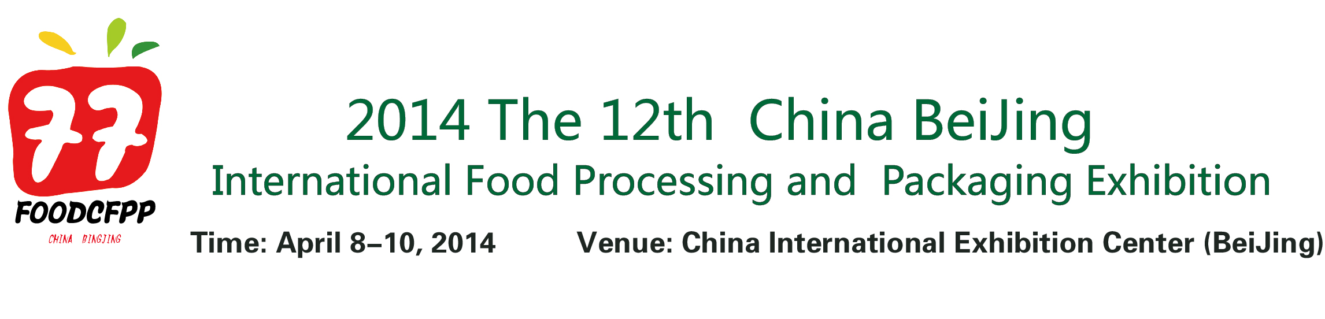

ORGANIZING UNITS
- China National Food Industry Association（CNFIA）
- The International Food Packaging Association
- Beijing JingMao International Exhibition Co., Ltd
Co-organizer:
- Association for Healthcare Foodservice
- China Food Newspaper、China Food Quality Newspaper……
Organized by：
- Beijing JingMao International Exhibition Co., Ltd
- Jingmao Exhibition Service (Shanghai) Co., Ltd.
- Market Development of China National Food Industry Association
[Exhibition review]
Since successfully originated in 2013, China International Food Packaging and Processing Equipment Exhibition has been held for eleven times, the scale has been greatly expanded, the number of professional audiences has gradually increased, the exhibition benefit has been obviously improved, and the influence also rose up greatly. CF has become one of largest, influence and potential food industry exhibitions. In the past 11 years, CF brought together with over 1800,000 trade visitors from 46 countries and regions.
The huge potential market attracts global attention. CF-2014 is expected to cover a space of 50,000 square meters and attracts over 600 exhibitors and 60,000 visitors worldwide, which will once again provide you with excellent trade opportunities and broad business platform.
The 12th edition CF will take place during April 8-10th, 2014 at China International Expo Centre, CF co-locating with CIFE China is the largest event ever organized for a completed chain from equipments to products in the field of international food and beverage market in China. the synergy of CIFE China and Packtech-Foodtech has attracted an increasing number of players in Food and beverage Industry, allowing visitors and exhibitors to take advantage of their synery.
[Schedule]
Construction: April6 - 7, 2014
Exhibition: April 8 –9,2014 (09:00 – 17:00)
April 10,2014 (09:00 – 16:00)
Dismantling: April 10,2014 (16:00 – 21:00)

[Scope of Exhibits]
FOOD MACHINERY
A. Food Processing Machinery
Soft Drink Processing
Pastry Processing
Candy Processing
Soy-Bean Products Processing
Fruits & Vegetables Processing
Slaughtering Machinery
Meat Processing
Milk Products Processing
Brewing Machinery
Flavoring Processing
Fat Deep Processing
Instant Food Processing
Grain Processing
Cooking Machinery

B. Processing Technology Equipment
Selecting, Washing and Brushing Machinery
Grinding and Separating Machinery
Food Mixing Machinery
Food Homogenizer
Food Concentrating Equipment
Food Drying and Sterilizing Machinery
Food Frying Machinery
Baking Machinery

PACKAGING MACHINERY
C. Decorating Printing Machinery
Wrapping Machinery
Vacuum Packaging Machinery
Forming-Filling-Sealing Machinery
Labeling Machinery
Strapping and Containering Machinery
Cleaning Machinery(Bottle Washing, Case washing)
Medicine Packaging Machinery
Packaging Container Making Machinery
Packaging Materials Processing Machinery

D. Other Relevant Machinery
Inkjet Printers
Testing Equipment
Transmission Machinery
Weighing Equipment
Equipment Components & Expendables
Food Grade Series Compressor Oil

[Participation Fee]
● Standard exhibition booth: 9 m2 (3mx3m); domestic enterprises: joint adventure enterprises /special seporation standard booth 12800 RMB / unit, foreign enterprises: 3000 USD / unit; an additional of 10% will be charged for booths with both opennings;
● Empty exhibition space (at least 36 m² to be leased): Domestic enterprises: 1200 RMB / m²; foreign-funded enterprises: 300 USD / m²;
● Professional seminar / technical exchange fair / new products releasing conference: Cost ￥ 10000 RMB at each show/ half an hour, The sponsor will provide the supporting facilities and supplies such as the sites, lights, sound, projectors, tables and chairs and assist the enterprise giving the speech to organize the audiences
● Ads
● Please contact the Organizing Committee for sponsoring the Exhibition and related activities,
[Clients aim at activity ]
Under the support of multi-media for promulgation, through letters, network, E-mail, media, press releases, major newspapers and academic exchanges, organizer will invite professional purchaser, meat and Meat Company, food factory, packing, processing, hotel, food and drink investment/ trade/ assessment/ design/ engineering/ consultation/research/ management/plan/supply/import and export/ government/ association/ academy/ institutions to attend the exhibition.
Professionals from the following fields:
◆Food processing / Fruit and vegetable processing; ◆ Drink / wine / beer manufacturing;
◆ Milk products / ice cream processing; ◆ Butcher factory/ meat processing;
◆Seasoning / food ingredients processing, ◆ Candy manufacturing;
◆Packing / Printing factory; ◆ Daily chemical industry/ pharmaceuticals manufacturing
◆Tobacco manufacturer ◆ Food processing and mechanical manufacturers;
◆Packing mechanical manufacturer ◆ Hotel/ grogshop/food & beverage;
◆Dealer / trade agent / importer and exporter / wholesaler / distributor;
◆Scientific research consultant /media /government and association

[Participation Procedure]
1. Please fill out the "Exhibitor Application Form" for exhibitor with official seal, send or fax it to the organizing committee. Remit the participation cost to the designated account of organizing committee in 5 days. The allocation of exhibition position will be made according to the sequence order of the payment. It will be stopped until there is no vacant seat left.
2. After the exhibitor remits the money, he should fax or mail the bank remittance to the organizing committee for the verification. The finance department of the organizing committee will make out an invoice for the exhibitor who has paid all the money in 5 days. For the exhibitor who has only paid the deposit, the organizing committee will negotiate the concrete matters of invoice with the exhibitor.
3. All exhibitors must be the companies which have got legal power of operation in Chinese territory, any units and individuals can not bring fake and forged products to the exhibition, otherwise the organizing committee will have the right to cancel its participation right in the exhibition.
Liaison Department of the Organizing Committee:
Add: Room 2705, G Block of city one 48#, Wangjing West Road, Beijing, China .
Postcode: 100102
Tel: 86-10-64787342 86-10-84414061
Fax: 86-10-58043750
E-mail:fengfeng99@VIP.163.com

